

Ravidu sadaruwan abeywardana

**Employee Motivation and Engagement Survey**

Draft



Table of Contents

Introduction: 2

Purpose: 2

Method: 2

Nature of Survey: 3

Benefits of the Survey: 3

Risks 4

Questions 5

Timeline 7

GANTT Chart: 7

References: 8

# Introduction:

This survey has been developed to delve into the various factors that impact employee motivation and engagement within a range of workplace settings. In today's dynamic work environment, understanding what drives and sustains employee motivation is crucial for both organizational success and individual well-being (Park, 2023). By participating in this survey, employees contribute to a broader understanding of experiences across different industries and organizations. It is essential to ensure that employees remain motivated and engaged to promote productivity, job satisfaction, and overall organizational success (Wang and Panaccio, 2022). The survey is designed to gather insights into the current state of employee motivation and engagement, identify potential areas for improvement, and contribute to the enhancement of our work environment.

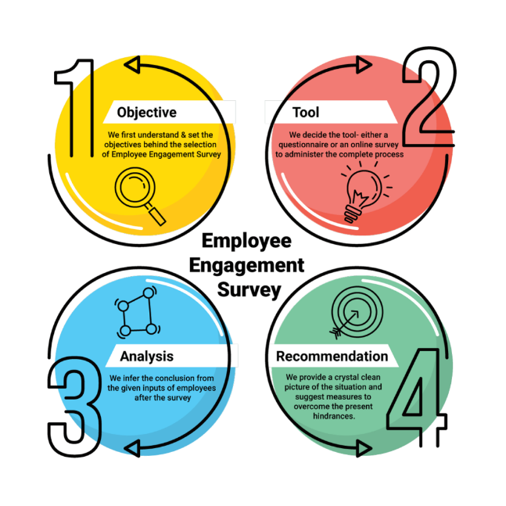

# Purpose:

The information gathered from this survey will offer valuable insights into the factors influencing employee motivation and engagement. Through the collection of data from a diverse range of participants, the researcher aims to pinpoint common patterns, best practices, and potential areas for enhancing a motivated and engaged workforce. Such findings will enable companies to craft focused strategies and interventions geared towards elevating employee satisfaction, commitment, and performance.

# Method:

Due to time constraints and the goal of reaching a diverse audience, the survey will be distributed electronically through multiple channels, including email, WhatsApp, and LinkedIn. This approach enables efficient data collection and a wider outreach. The researcher aims to collect responses from a diverse sample of at least 50 employees across different industries and job roles.

# Nature of Survey:

The survey will be designed with the utmost care to ensure simplicity and clarity. When designing the survey, careful consideration will be given to ensure that the questions are straightforward and easy to understand. The researcher will avoid loaded questions that might bias responses and use layman's language to ensure clarity. The questions are aimed at gathering diverse viewpoints, ensuring that everyone's feelings and perspectives are valued. The survey will be structured to capture various aspects of motivation and engagement, including job satisfaction, work-life balance, opportunities for growth, and relationship with supervisors and colleagues.

This survey has been designed with efficiency in mind, and it is anticipated to take approximately 10 minutes to complete. The survey format will incorporate multiple-choice questions (MCQs) that can be answered with a simple "yes" or "no," as well as short-answer questions that allow respondents to provide more detailed insights.

# Benefits of the Survey:

The survey will provide benefits to each party as below:

|  |  |
| --- | --- |
| Party | Benefits |
| Employees | Gain insights into their own motivation and engagement levels, potentially leading to increased job satisfaction. |
| Employers | The survey will grant employers access to valuable information, enabling them to enhance their understanding of employee needs and tailor strategies aimed at improving motivation and engagement within the workplace. |
| Research | The survey will contribute to the body of knowledge on employee motivation and engagement, playing a significant role in the development of evidence-based practices and fostering advancements in the field. |
| Organization | will enable organizations to develop targeted strategies that foster a more motivated and engaged workforce. This, in turn, can lead to improved productivity and higher employee retention rates |
| Training and Development Teams | Survey insights can guide the design and implementation of training programs aimed at addressing specific areas identified by the survey, leading to better-skilled employees. |

# Risks

* Ethical Concerns: Ensuring participant confidentiality and anonymity could be challenging, potentially leading to hesitancy in responding truthfully.
* Bias and Interpretation: Biased survey questions or interpretations could skew results and affect the accuracy of findings.
* Low Response Rate: If the response rate is low, the survey results may not represent the entire employee population accurately.
* Survey Fatigue: Frequent surveys or lengthy questionnaires might lead to participant fatigue and reduced quality of responses.
* Misinterpretation of Findings: Misinterpreting survey findings could lead to ineffective or misguided interventions.

The following table includes measures designed to address the mentioned risks,

|  |  |
| --- | --- |
| Risks | Measures |
| Ethical Concerns | - Clearly communicate participant confidentiality and anonymity  - Implement secure data practices. |
| Bias and Interpretation | - Design neutral and unbiased questions  - Do a pilot test for accurate interpretation. |
| Low Response Rate | - Use reminders and user-friendly design to encourage participation. |
| Survey Fatigue | - Keep the survey concise and communicate its importance. |

# Questions

The questions will be sectioned as below,

**Section A: Demographic Information**

In this section, the researcher will collect demographic details to understand the diversity of participants and its potential influence on motivation and engagement. The questions may include:

* Age
* Gender
* Education level
* Job role and department
* Years of experience

**Section B: Current Job Satisfaction and Work-Life Balance**

This section aims to gauge participants' current level of job satisfaction and their perception of work-life balance. Questions could cover:

* Overall job satisfaction
* Satisfaction with compensation and benefits
* Workload and stress levels
* Flexibility in work arrangements
* Perception of work-life balance

**Section C: Growth and Development Opportunities**

This section focuses on employees' perceptions of growth and advancement opportunities within their organizations. Questions may include:

* Opportunities for skill development and training
* Clarity about career paths and advancement
* Support for professional growth
* Feedback and performance evaluation processes

**Section D: Interpersonal Relationships and Team Dynamics**

This section explores the relationships employees have with their colleagues and supervisors, as well as the team dynamics within the organization. Questions could cover:

* Relationship with immediate supervisor
* Collaboration and communication within teams
* Sense of belonging and teamwork
* Support from colleagues

**Section E: Overall Motivation and Engagement**

This final section delves into participants' overall motivation and engagement levels. Questions may include:

* Intrinsic motivation factors (e.g., sense of purpose, mastery)
* Extrinsic motivation factors (e.g., recognition, rewards)
* Factors that contribute to disengagement
* Suggestions for improving motivation and engagement

# Timeline

* Survey Design and Question Development: August 12 to August 14
* Pilot Testing: August 15 to August 16
* Finalizing Survey: August 17 to August 18
* Survey Distribution and Data Collection: August 19 to August 30 (participants respond online)
* Data Analysis and Reporting: August 31 to September 02

# GANTT Chart:

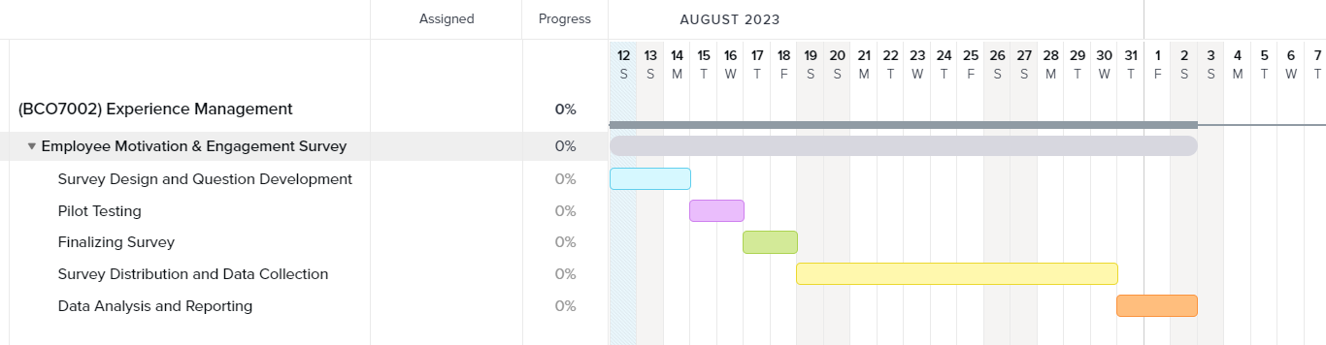

# References:

* BUSHI, F. (2021) ‘An Overview of Motivation Theories: The Impact of Employee Motivation on Achieving Organizational Goals’, *Quality - Access to Success*, 22(183), pp. 8–12. Available at: https://research.ebsco.com/linkprocessor/plink?id=51150f9b-070a-3b4a-bb44-56e34b748e5f (Accessed: 9 August 2023).
* Grabowski, D., Chudzicka-Czupała, A. and Stapor, K. (2021) ‘Relationships between work ethic and motivation to work from the point of view of the self-determination theory’, *PLoS ONE*, 16(7), pp. 1–17. doi:10.1371/journal.pone.0253145
* Park, R. (2023) ‘What if employees with intrinsic work values are given autonomy in worker co-operatives? Integration of the job demands–resources model and supplies–values fit theory’, *Personnel Review*, 52(3), pp. 724–744. doi:10.1108/PR-05-2021-0362.
* Pincus, J.D. (2022) ‘Employee Engagement as Human Motivation: Implications for Theory, Methods, and Practice’, *Integrative Psychological and Behavioral Science*, pp. 1–33. doi:10.1007/s12124-022-09737-w.
* Wang, Z. and Panaccio, A. (2022) ‘A Longitudinal Investigation of the Changes in Work Motivation and Employees’ Psychological Health’, *Administrative Sciences (2076-3387)*, 12(4), p. 193. doi:10.3390/admsci12040193.